**MTE 562 Computer exercise 2**

**Thermodynamics measurement using DSC**

Mikko Karkkainen 11740378

The equations for the calculation of change in gibbs energy, enthalpy and entropy in solid and liquid phases of indium were investigated using DSC. Figure 1 shows the experimental data from the measurement. The large peak at approximately 155 C° represents the enthalpy of fusion. The DSC software determined the value for the enthalpy of fusion as:

Additionally, the melting point was determined to be:

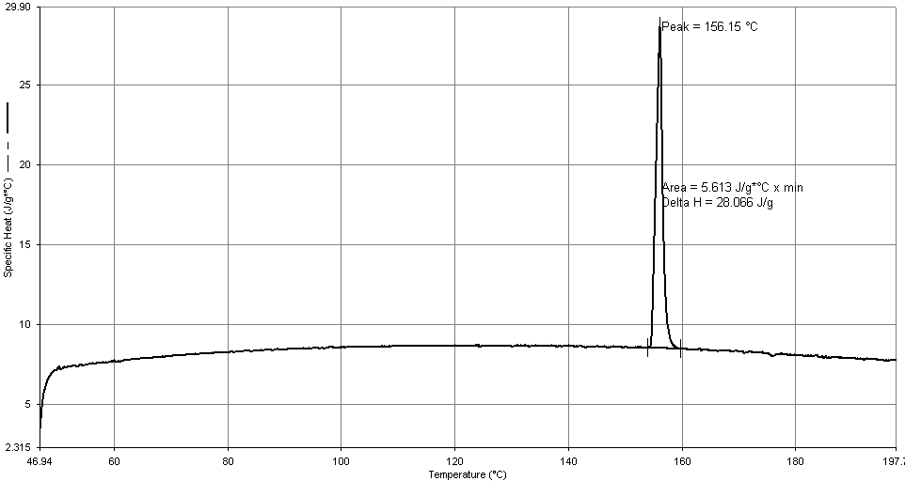

Figure 1. experimental value of Cp (J/gC°) as a function of temperature (C°) from DSC software

To determine a mathematical expression for the function of in the solid phase, a 2nd order polynomial was fitted to the experimental data at the interval of

The fitting is shown in figure 2. The equation for in the solid phase was determined to be:

The same approach was used to determine the equation for in the liquid phase, as shown in figure 3. The temperature range used was:

The resulting equation is:

Figure 2. as function of Temperature for solid and 2nd order polynomial fitting

Figure 3. vs Temperature for liquid and 2nd order polynomial fitting

**Determining enthalpy:**

Enthalpy change for solid phase can be determined from the following function:

Enthalpy change for liquid phase can be determined from the following equation:

The enthalpy of fusion is given by:

Inserting values and calculating yields:

**Determining entropy:**

Entropy change can be determined from the following equation:

Where is the final temperature. Inserting values and calculating yields:

**Determining Gibbs energy:**

Gibbs energy change can be determined from the following equation:

Using the equations for and yields:

**Comparing with HSC**

The HSC software uses the units J/(molK) and J/(mol) for instead of J/(gK) and J/g received from the experiments. We must convert the HSC data to be comparable. Figure 4 shows the measured Cp and the Cp values given by HSC side by side for indium.

Figure 4.